The Hidden Beauty of the Double Pendulum Abstract

Josh Greensmith

The aim of this investigation was to research the interesting and bizarre physical properties of the double pendulum and learn more about chaotic systems in the process. The property that I mainly looked at was the flip time which was displayed on a 2D colour map using a computer simulation built from scratch. There were three steps to investigating this interesting behaviour: first I derived the equations of motion for the double pendulum system, then I wrote a simulation in Python that integrated the equations of motion numerically giving the colour map results and finally I analysed these results.

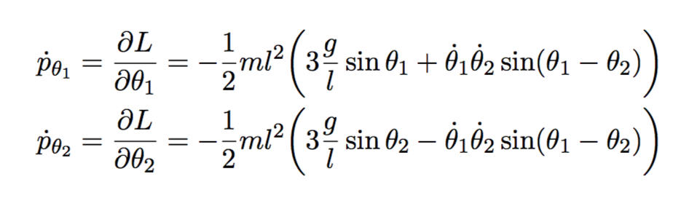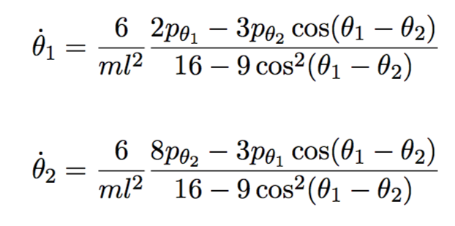To derive the equations of motion I started with what I knew about the system and the energy characteristics based on the positions of the two pendulums to define the Lagrangian. The Lagrangian is the difference in kinetic and potential energy of a system and can be partially differentiated with respect to different variables to find the rate of change of the angles and momenta of both pendulums. The differential equations that followed are known as the *characteristic equations* of the system that define the motion of the double pendulum. The motion of the two pendulums produces an interesting behaviour which I called *flip time* which is the time for the bottom pendulum to flip over the vertical based on the initial conditions such as starting angles of both pendulums, their two masses and their lengths. The flip time was interesting a small change in the initial conditions could either cause a large change in the flip time or a small change so I decided to investigate this property further.

Unfortunately, the *characteristic equations* cannot be integrated analytically due to the chaotic nature of the system as a small change in the initial conditions leads to a large change in the outcome of the experiment. However, they can be numerically integrated using the *Euler method* to produce a visual simulation of the motion of the double pendulum; I coded this in JavaScript using the p5.js library (joshgreensmith.ml/DoublePendulum). It can also be integrated using less computational time by advanced methods such as the *Runge-Kutte method* which is adopted by the package *scipy.integrate.odeint* which I used to carry out the main investigation. I wanted to keep the masses and lengths fixed and vary the starting angles of both pendulums between their maximum values and minimum values and display the flip time for each angle. To do this I used a colour map with the angle of the first pendulum as the horizontal axis and the angle of the second pendulum as the vertical axis then displayed the flip time as a colour. I ran this simulation using a Python script at a resolution of 1500x1500 which took an average of 9 hours for each colour map to generate. Very interesting colour maps came out of this which had never been generated before; this meant that I was the first person to see these amazing patterns emerge from the behaviour of the double pendulum.

I then analysed these colour maps, trying to account for the symmetry and some of the changing behaviour between different colour maps as I changed the ratio of the masses to the lengths as the curves in the colour maps morphed and changed.

